Incident Report Form
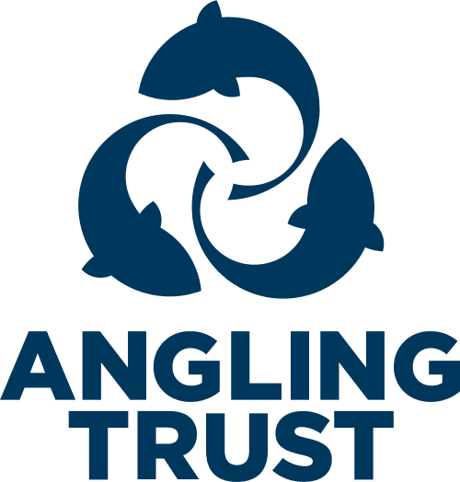

Use for reporting all safeguarding concerns. Such as poor practice, bullying, cases of emotional, physical, sexual abuse or neglect or anything that raises a concern.
Please complete in as much detail as possible before sending. The lack of contact information or detail can slow down agency responses and hamper investigations.
- Name of organisation:
Click or tap here to enter text.
- Your name:
Click or tap here to enter text.
- Your position:
Click or tap here to enter text.
- Your contact information:
Address (including postcode of club/fishery): Click or tap here to enter text.
Telephone number: Click or tap here to enter text.
Email address: Click or tap here to enter text.
- Name of Person/s concern relates to:
Click or tap here to enter text.
- Date of birth of person/s concern relates to:
Click or tap here to enter text.
- Is the person under 18? (If no, go to question 11)
Yes
No
- Parent/Carer’s contact information:
Name/s: Click or tap here to enter text.
Address: Click or tap here to enter text.
Telephone numbers: Click or tap here to enter text.
Email address: Click or tap here to enter text.
- Have parents/carer been notified of this incident (this should only not happen if incident or concern involves parents/carer:
Yes
No
- If YES, please provide details of what was said:
Click or tap here to enter text.
- Contact information of adult concern relates to:
Name/s: Click or tap here to enter text.
Address: Click or tap here to enter text.
Telephone numbers: Click or tap here to enter text.
Email address: Click or tap here to enter text.
- Person’s ethnic origin:
Click or tap here to enter text.
- Are you reporting your own concerns or responding to concerns raised by someone else:
Own concerns
Concerns raised by someone else
- If responding to concerns raised by someone else, please provide further information:
Name: Click or tap here to enter text.
Position within club/event: Click or tap here to enter text.
Telephone numbers: Click or tap here to enter text.
Email address: Click or tap here to enter text.
- Date, time and location (including Postcode if possible) of incident:
Click or tap here to enter text.
- Details of incident or concern: Include all relevant information, such as dates, times, description on any injuries and whether you are recording this incident as fact, opinion or here say.
Click or tap here to enter text.
- Child’s account of the incident: Complete if this report relates to a child
Click or tap here to enter text.
- Please provide any witnesses accounts of the incident:
Click or tap here to enter text.
- Please provide details of any witnesses to the incident:
Name: Click or tap here to enter text.
Position within club/event: Click or tap here to enter text.
Telephone number: Click or tap here to enter text.
Email address: Click or tap here to enter text.
- Please provide any details of any person involved in this incident or alleged to have caused the incident/injury:
Name: Click or tap here to enter text.
Person within the club or relationship to the child: Click or tap here to enter text.
Date of birth: Click or tap here to enter text.
Address: Click or tap here to enter text.
- Please provide details of action taken to date:
Click or tap here to enter text.
- Has the incident been reported to any external agencies?
Yes
No
- If YES, please provide further details:
Name of organisation/agency: Click or tap here to enter text.
Contact person: Click or tap here to enter text.
Telephone numbers: Click or tap here to enter text.
Email address: Click or tap here to enter text.
Agreed action or advice given: Click or tap here to enter text.

Your signature: | Click or tap here to enter text. | Print name: | Click or tap here to enter text.
Date: | Click or tap here to enter text.

Contact the Angling Trust’s Designated Safeguarding Officer in line with reporting procedures. Safeguarding@anglingtrust.net

